**Assignment** : 14

**Title** : Create an elastic IP for an instance.

**Disadvantage of using public IPv4 address** : One of the biggest benefits of compute capacity in cloud such as EC2 is to be able to start, stop, hibernate or terminate your instance within a matter of seconds.However, there is a downside as well. If you stop your EC2 instance and start it again, the IP address of your instance changes. That means your instance is no longer accessible using your old IP address.

For example : If you are hosting your application on EC2 and the public IP changes. Your application becomes inaccessible.You might think that you will use the new IP address instead. Well that will work of course. But what if you are using a custom domain name where you have specified the IP address of the instance. It is almost impossible and impractical to update the A record manually each time IP address changes.

### The solution is to attach an Elastic IP to your instance. Now even if your system stops , starts or hibernate, your instance has elastic IP attached to it. Even if your instance got terminated somehow, you can launch a new instance and attach the same elastic IP to new instance.

An **Elastic IP** is a static public IP address that you can allocate to your AWS account. Once allocated, you can associate this elastic IP to any of your EC2 instance, disassociate from one instance and re-associate to another.That means it’s a reserved public IP address that you can assign to your EC2 instance.

**Steps to create an elastic IP :**

1. **Steps to Create an instance** :
2. Open the Amazon EC2 console.
3. From the EC2 console dashboard, Click on I**nstances(Running**), choose **Launch instance.**

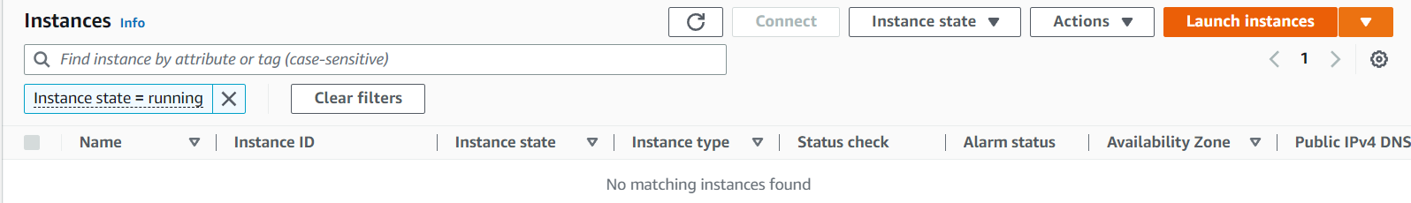

and The **Launch an instance** page opens..

1. Under **Name and tags**, for **Name**, enter a descriptive name for your instance like ‘ **Snehaec2WebServer** ’.
2. Under **Application and OS Images (Amazon Machine Image)**, do the following:

Choose **Quick Start**, and then choose **Ubuntu**. This is the operating system (OS) for your instance,

which is Free Tier Eligible.

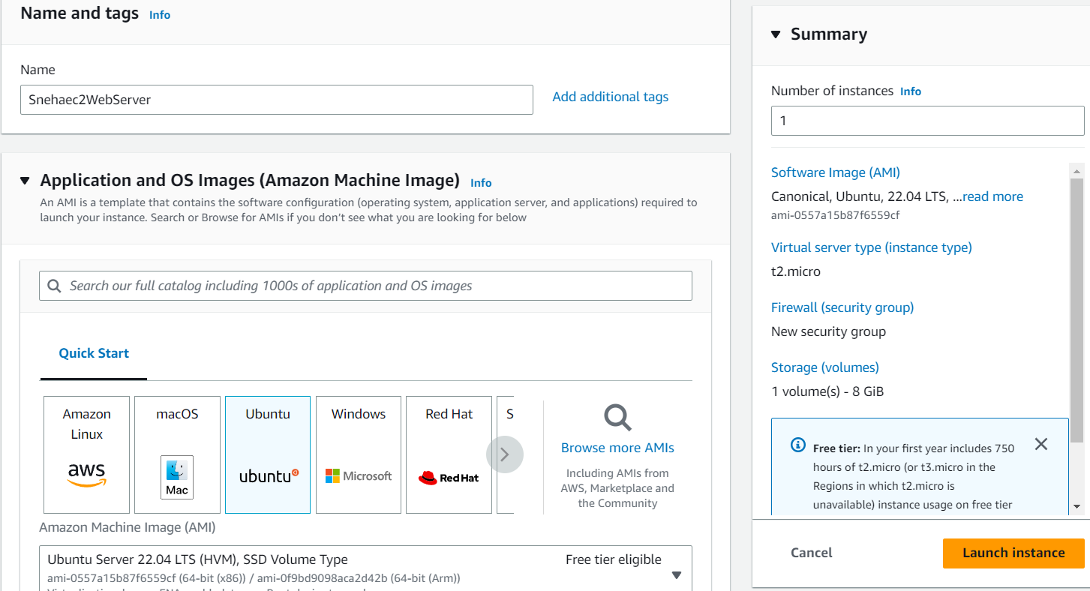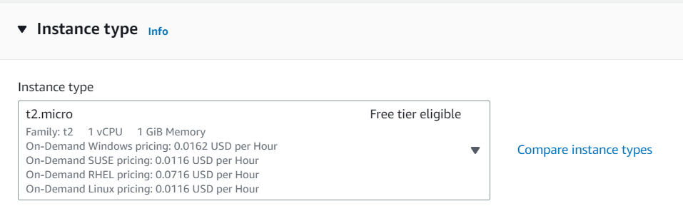

Under **Instance type**, from the **Instance type** list, you can select the hardware configuration for your instance. Choose the t2.micro instance type, which is selected by default. The **t2.micro** instance type is eligible for the free tier.

1. Under **Key pair (login)**, for **Key pair name**, choose the key pair that you created already or Choose **Create new key pair**. A dialogue box opens - Give a name to the key pair under the **Key pair name** like **snehaa1234**

The key pair generated is of:

1. Type - **RSA**
2. File format - **.pem**

Click on **Create key pair** and the .pem file of your key pair is automatically downloaded. And is saved for further use.



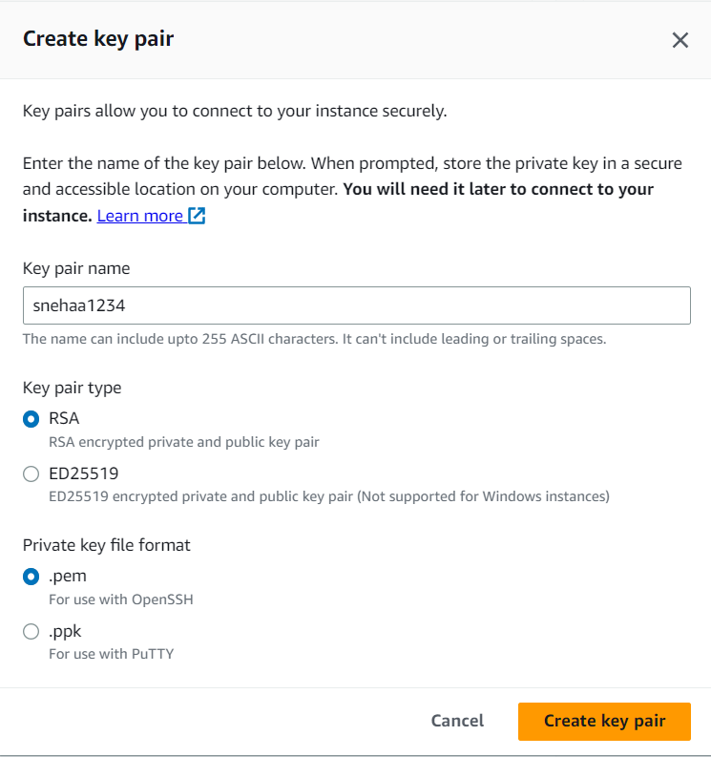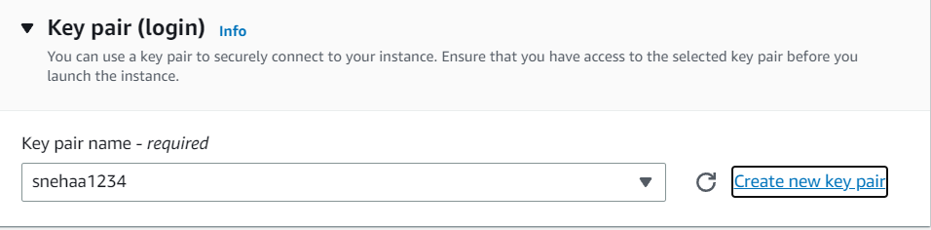

1. In **Network settings** , under the **Firewall (Security groups)** there is a by default selection of **Create security Groups** under which check or select all the three boxes namely :

* **Allow SSH traffic from** - Helps you connect to your instance
* **Allow HTTPS traffic from the internet** - To set up an end point.
* **Allow HTTP traffic from the internet** - To set up an endpoint .

1. Keep the default selections for the other configuration settings for your instance.Review a summary of your instance configuration in the **Summary** panel, and when you're ready, choose **Launch instance.**

A confirmation page lets you know that your instance is launching. Choose **View all instances** to close the confirmation page and return to the console.

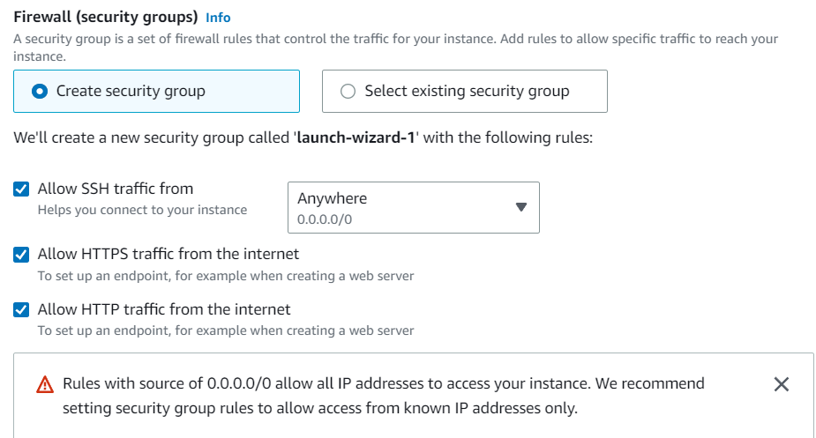 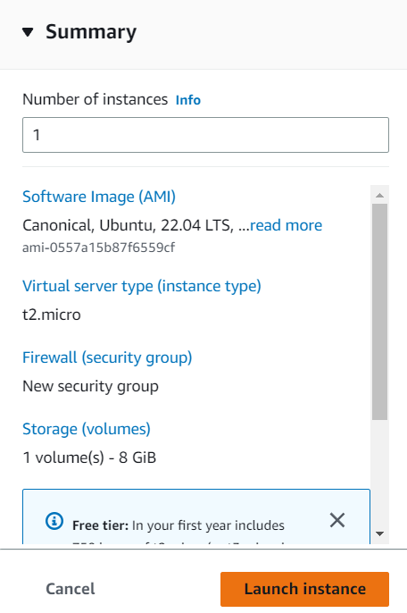

1. Save the public IPv4 address and stop the instance (Instance state->stop instance)

, keep a note of the IP address.

1. Now run the same instance (Instance state->start instance)and check the Public

ipv4 address again , you can see the address has changed.

 

1. Now create Elastic IP .

**Network & Security -> Elastic IPs -> Allocate Elastic IP Address**

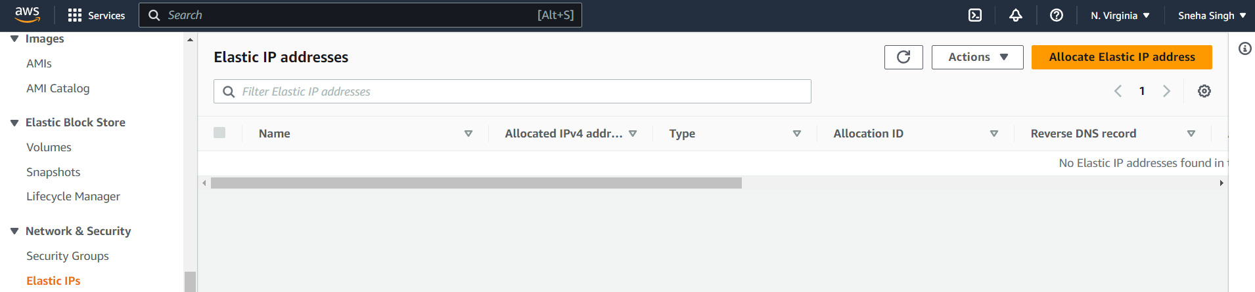

Allocate the Elastic IP Address by clicking Allocate.

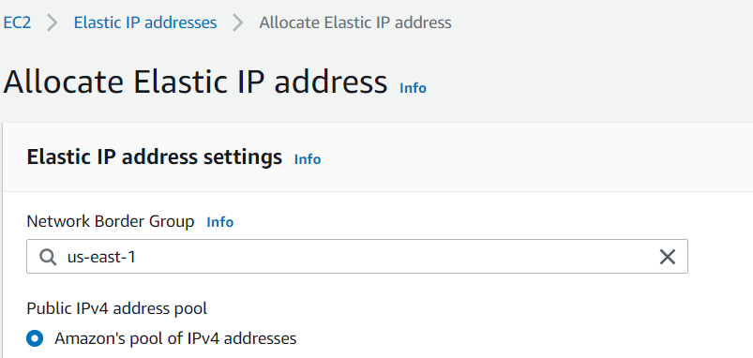 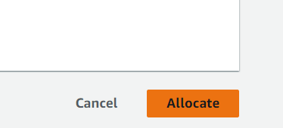

1. Now we will associate the IP address.

Click on IP address you created and then click on **Associate Elastic IP Address**.

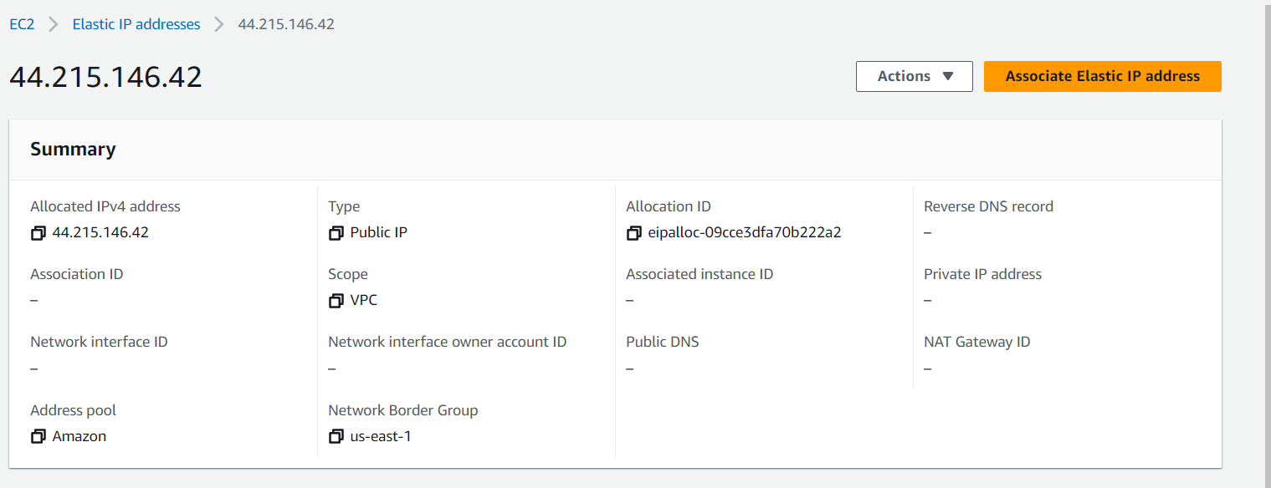

**Resource Type** - choose Instance

**Instance** - choose the current running instance allocated with elastic IP

**Private IP** Address - Default

Tick the box - **Allow this Elastic IP address to be reassociated**

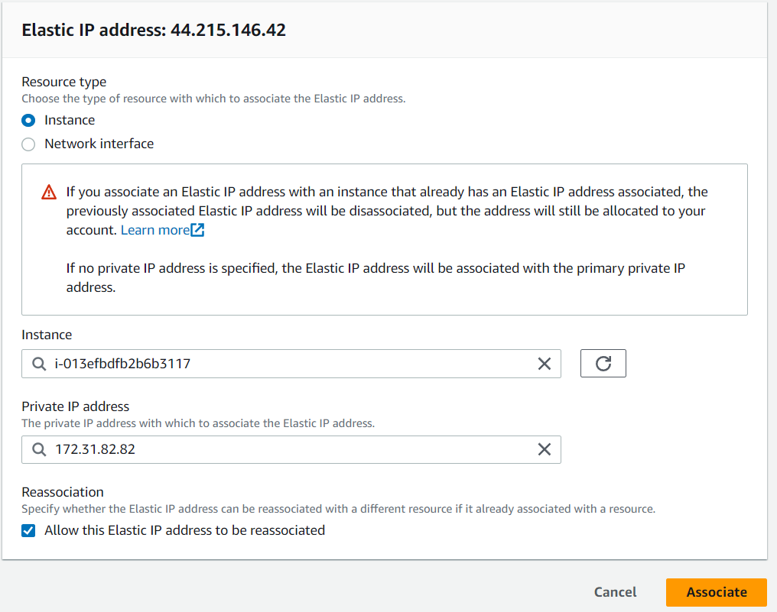



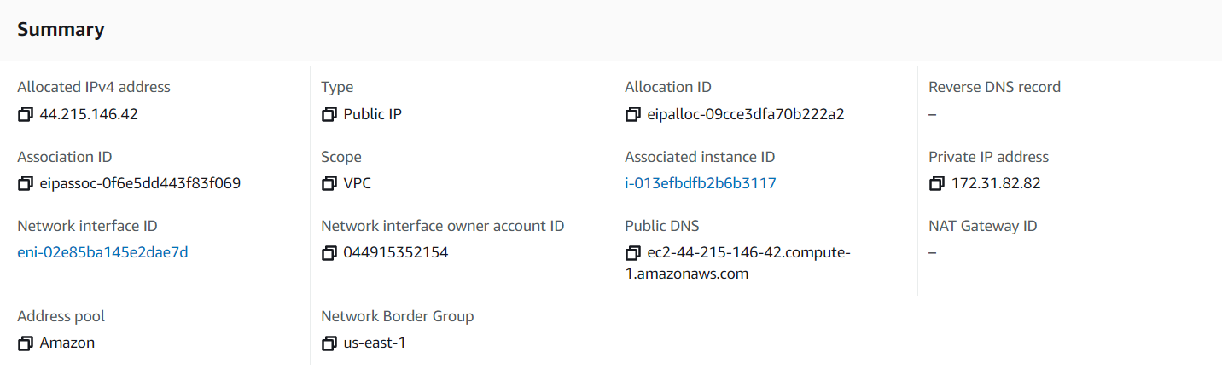

1. Save the public IPv4 address and stop the instance (Instance state->stop instance)

, keep a note of the IP address.

1. Now run the same instance (Instance state->start instance) and check the Public

ipv4 address again , you can see the address has not changed this time.

That’s the final job for the elastic IP.

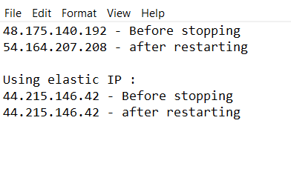

H.To delete The Elastic IP :

* Disassociate Elastic IP Address
* Release Elastic IP Address

